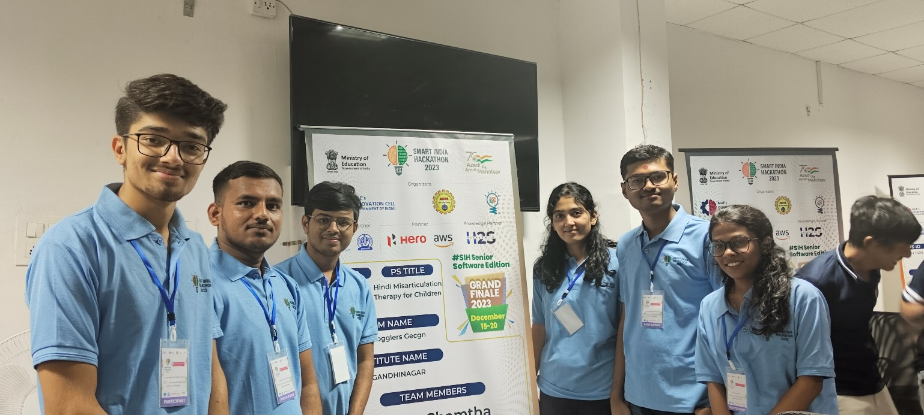

We are happy to announce that our team "Mind Bogglers GECGn" successfully participated in Smart India Hackathon Grand Finale 2023 at Techno India NJR Institute Of Technology, Udaipur, Rajasthan and secured 2nd rank in SIH problem statement 1405 there. This is a very proud moment for us. And we are very grateful to our college Government Engineering College Sector-28, Gandhinagar that due to the hard work of the college and professors we have reached this point.

- Our Problem Statement: - Develop therapy materials in Hindi for misarticulation children. (SIH 1405)

- Our Team Members Details: -

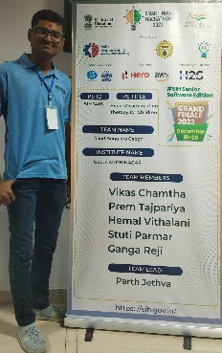

1. Our team leader Parth Jethva who is from BM Department. Who has led the entire team very enthusiastically and intelligently and his role was flutter frontend developer.

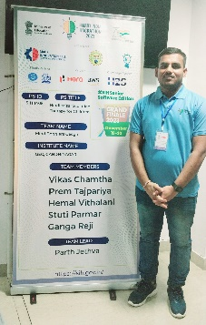
2. Our second team member Vikas Chamtha who is from IT department played the role of flutter Backend Developer in Our project. His role in project development was very important.

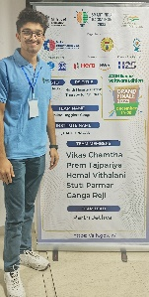
3. Our third team member Hemal Vithalani who is from IT department played the role of content creator like presentation, prototype etc. throughout the project.

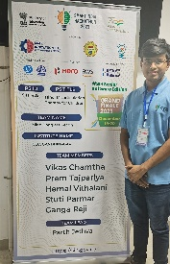
4. Our fourth team member Prem Tajpariya who is from BM department contributed to the project as product designer.

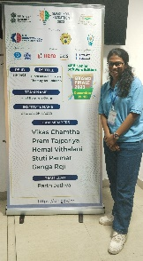
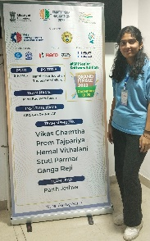
5. Our last two team members are Stuti Parmar and Ganga Reji who are also from the BM department. They provided the technique for speech therapy and Hindi Voice Articulation therapy throughout the project. They made an important contribution to our project as a researcher.

- So, this was a short introduction about our team. Our experience at the SIH Grand Finale 2023 was great. We hope that our experience is very valuable and will help us to scale the heights of success in the future.

